# Deploy the Polls app to [www.pythonanywhere.com](http://www.pythonanywhere.com):

By Marvin, Feb/1/2020

1. Go py_django2\web_project (my project folder), and run pip freeze > requirements.txt
2. Push files to github repo: <https://github.com/marvinxu99/py_django2.git>
3. Go to pythonanywhere.com, create a beginner’s account at <https://www.pythonanywhere.com/>

User: winnpy/mxx.2xxx

1. Launch a Bash console from PythonAnywhere

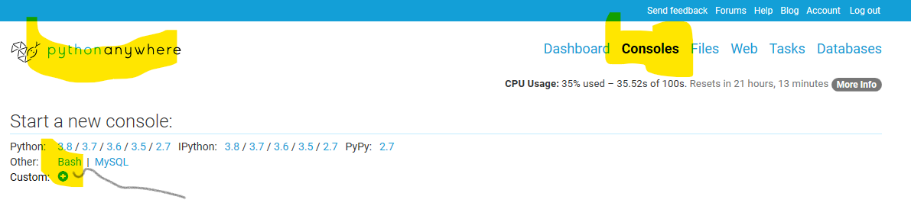

1. Run git clone <https://github.com/marvinxu99/py_django2.git> in Bash
2. run ls to confirm the folder py_django2 and files are cloned
3. cd py_python2/web_project
4. Make a virtual env for the web app (https://help.pythonanywhere.com/pages/Virtualenvs)

$ mkvirtualenv myvirtualenv --python=/usr/bin/python3.8

1. $ which python

/home/winnpy/.virtualenvs/myvirtualenv/bin/python

1. $ workon myvirtualenv, to use the venv if needed
2. $ pip install -r requirements.txt . it should install Django 3.0.2 and other packages.
3. $ python manage.py migrate – to create all the sqlite3 database tables needed for auth,
4. $ python manage.py createsuperuser – create super user and other users to create the site
5. Go to pythonanywhere dashboard, and create a new app:

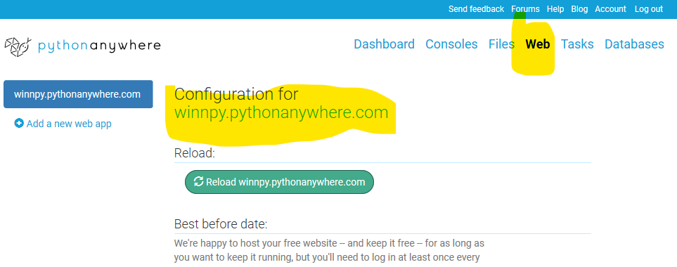

1. Select “Manual configuration” - select python3 + Django
2. Set up the folders information for the app:

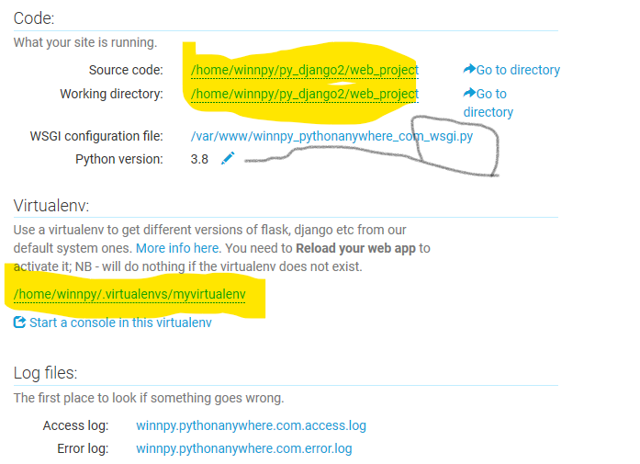

1. For the settings in winnpy_pythonanywhere_com_wsgi.py, edit the Django section accordingly, but delete or comment out all other sections.

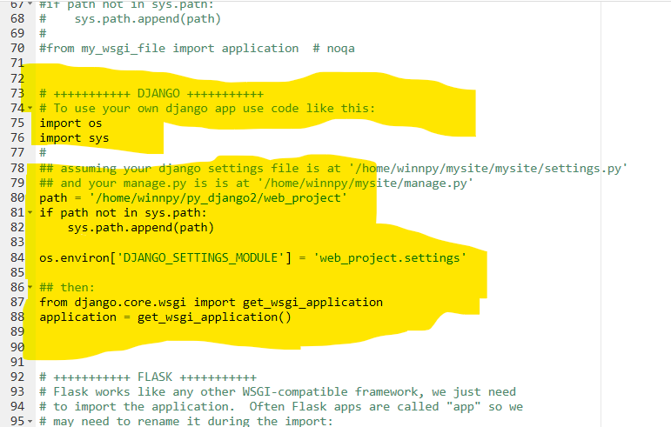

1. Also edit py_django2\web_project\web_project\settings.py.

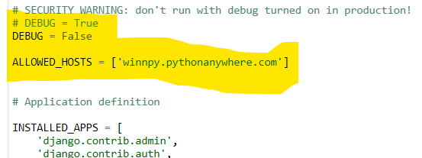

1. Reload your app, and then open and enjoy it!